WAS UND WANN?
___________________________________________________________________________

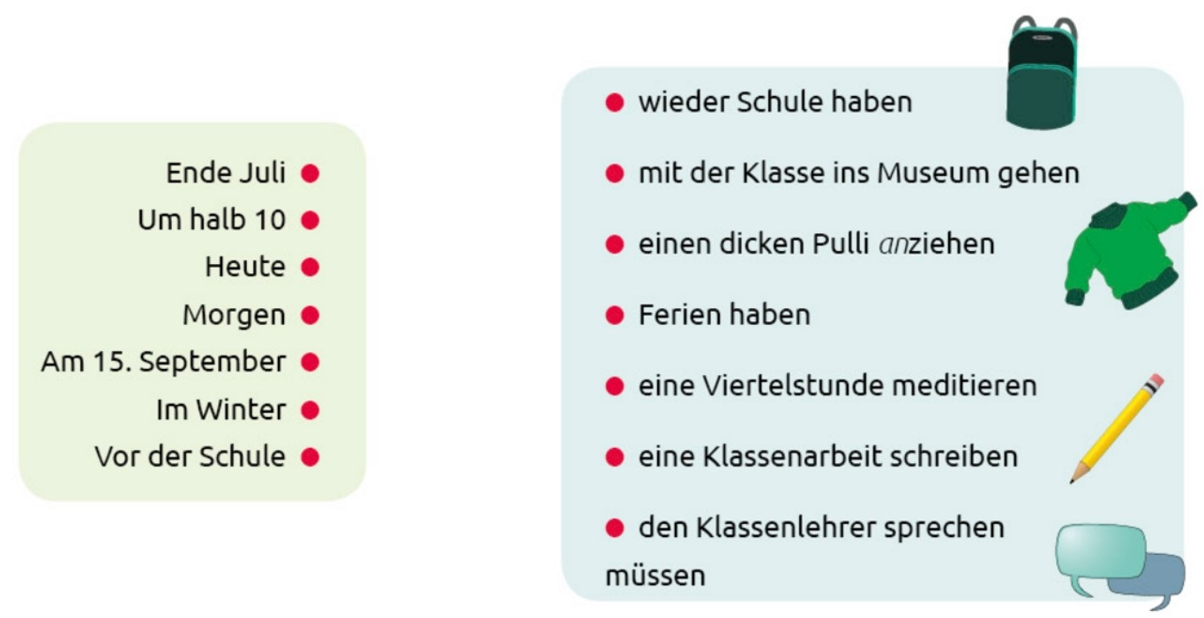
➫ Was macht Charlotte wann? Verbinde die Aktivitäten mit den Zeitangaben.

➫ Was macht Charlotte wann? Bilde Sätze mit den Zeitangaben.

- …………………………………………………………………………………………………………………………………….
…………………………………………………………………………………………………………………………………….

- …………………………………………………………………………………………………………………………………….
…………………………………………………………………………………………………………………………………….

- …………………………………………………………………………………………………………………………………….
…………………………………………………………………………………………………………………………………….

- …………………………………………………………………………………………………………………………………….
…………………………………………………………………………………………………………………………………….

- …………………………………………………………………………………………………………………………………….
…………………………………………………………………………………………………………………………………….

- …………………………………………………………………………………………………………………………………….
…………………………………………………………………………………………………………………………………….

- …………………………………………………………………………………………………………………………………….
…………………………………………………………………………………………………………………………………….

