DIE DEUTSCHEN MARKEN (II)

___________________________________________________________________________

**➫ Fülle die Tabelle mit einer Marke aus!**

|  |  |  |  |  |
| --- | --- | --- | --- | --- |
| Küche | Garage | Badezimmer | Mäppchen | Kinder |
|  |  |  |  |  |

**➫ Was stellen folgende Firmen her?**

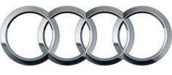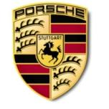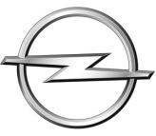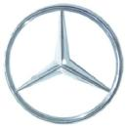

1. ……………………………………………………………………………………………………………………………

……………………………………………………………………………………………………………………………

[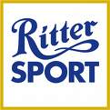](http://images.google.de/imgres?imgurl=http://www.deutschmobil.com/Logo%20Ritter%20Sport.JPG&imgrefurl=http://www.deutschmobil.com/pages/partenaires.htm&h=354&w=354&sz=44&hl=fr&start=1&tbnid=iPfdSUOWSEBdaM:&tbnh=121&tbnw=121&prev=/images?q%3Dlogo%2Britter%2Bsport%26svnum%3D10%26hl%3Dfr%26lr%3D)[](http://images.google.de/imgres?imgurl=http://www.kraftfoods.at/kraft/images/atde1/pictures/3_2_2_Milka%20Logo%20neu%203D.jpg&imgrefurl=http://www.kraftfoods.at/kraft/page?siteid%3Dkraft-prd%26locale%3Datde1%26PagecRef%3D515%26Mid%3D515&h=330&w=595&sz=70&hl=fr&start=2&tbnid=JACdfHfa-Vs0_M:&tbnh=75&tbnw=135&prev=/images?q%3Dlogo%2Bmilka%26svnum%3D10%26hl%3Dfr%26lr%3D%26sa%3DN)

1. …………………………………………………………………………………………………………………………….



1. ……………………………………………………………………………………………………………………………

[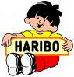](http://images.google.de/imgres?imgurl=http://neigeazur.ifrance.com/images/logos/logo_haribo.jpg&imgrefurl=http://neigeazur.ifrance.com/liens.html&h=166&w=160&sz=12&hl=fr&start=2&tbnid=F0oE5vK6l011WM:&tbnh=99&tbnw=95&prev=/images?q%3Dlogo%2Bharibo%26svnum%3D10%26hl%3Dfr%26lr%3D)

1. ……………………………………………………………………………………………………………………………